Gel Therapy Balls User instructions

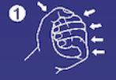
      - Hold the ball in your hand. Press the ball.

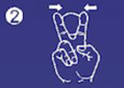
      - Use your index and middle finger to hold the ball. Bend your fingers down.

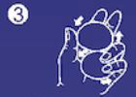
      - Hold two balls in your hand. Move one ball up and the other ball down at the same time.

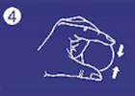
      - Use your thumb and index finger to squeeze the ball.

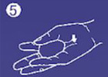
      - Place the ball in your hand. Use your thumb and little finger to squeeze the ball.

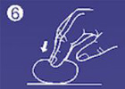
      - Place the ball on a flat surface. Use your fingertips to press the ball.

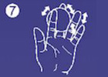
      - Move the ball through all fingers.

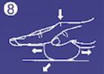
      - Place the ball on a flat surface. Use your palm to press the ball.

Attention! Do not overuse. Overuse can lead to muscle fatigue of your hand and wrist. Do not put the ball in your mouth.

Care instructions Do not expose to sunlight and do not place in humid areas. Before storing, clean with warm water. Wipe dry and apply some baby powder.
Made of TPR (thermoplastic rubber).

